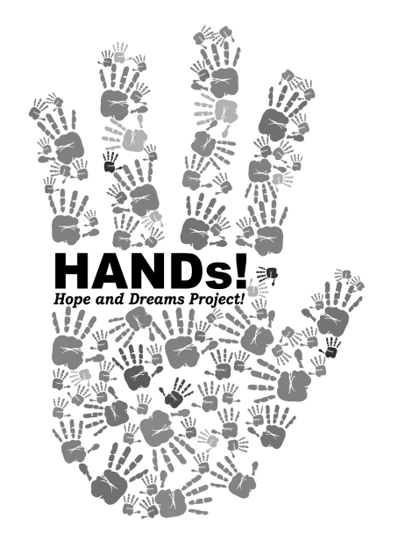
APPLICATION FORM
HANDS! PROJECT FOR DISASTER AND ENVIRONMENTAL EDUCATION + CREATIVITY 2016–2017
Please fill in the blanks wherever applicable. The completed application form and other supporting documents must be submitted to press [at] jfkl.org.my by 4.30 p.m. on Wednesday, 27 July, 2016
PERSONAL INFORMATION
[Attach photo here] | Full name
 | Date of birth | dd/mm/yy | Gender |  |  | ( ) Male |  |  | Are you Malaysian? |  | ( ) Yes
 |  |  |  |  |  | ( ) Female |  |  |  |  | ( ) No
 | Home address
Email address |  |  |  |  | Contact no.
Language Proficiency | English |  |  | ( ) Fluent |  |  | ( ) Fair |  |  | ( ) Poor
 | Other ( ) |  |  | ( ) Fluent |  |  | ( ) Fair |  |  | ( ) Poor
 | Other ( ) |  |  | ( ) Fluent |  |  | ( ) Fair |  |  | ( ) Poor
PROFESSIONAL AFFILIATION
Organisation
Office address
Area of specialty |  | Position
MISCELLANEOUS
How did you learn about the HANDs! Project?
Preferred method of correspondence
BACKGROUND, EXPERIENCE & IDEAS
- Do you have any international work, study and/or travel experience? Briefly describe, if any (max. 200 words).
- Briefly describe your professional, freelance, voluntary and/or internship experience (max. 300 words).
- Briefly describe your educational background and personal interests (max. 200 words).
- How do you think your experience, education and personal interests align with the HANDs! Project? (max. 200 words)
- Do you have any experience in disaster risk reduction and/or environmental issues? Briefly describe, if any (max. 200 words).
- HANDs! Project Fellows are expected to propose as an individual or group a disaster education and/or environmental protection related project upon completion of the research tours. If approved, you will be given seed funding to implement the project. Briefly describe an action plan you would like to develop, making sure to include your target beneficiaries, methodology, the role of creative arts within the project, and budget (max. 400 words).
- Do you have anything else you would like to tell us to set you apart from the other candidates? (max. 200 words)
I hereby certify that all the information given above is true and accurate.
…………………………………………………………………………….  SIGNATURE | …………………………………………………………………………….  DATE
The application form must be submitted with the following documents:
- CV in English (must not exceed 5 pages)
- Two work samples, e.g. short essays, news articles, journal articles, graphic designs, illustrations, photo essays, videos, etc.

