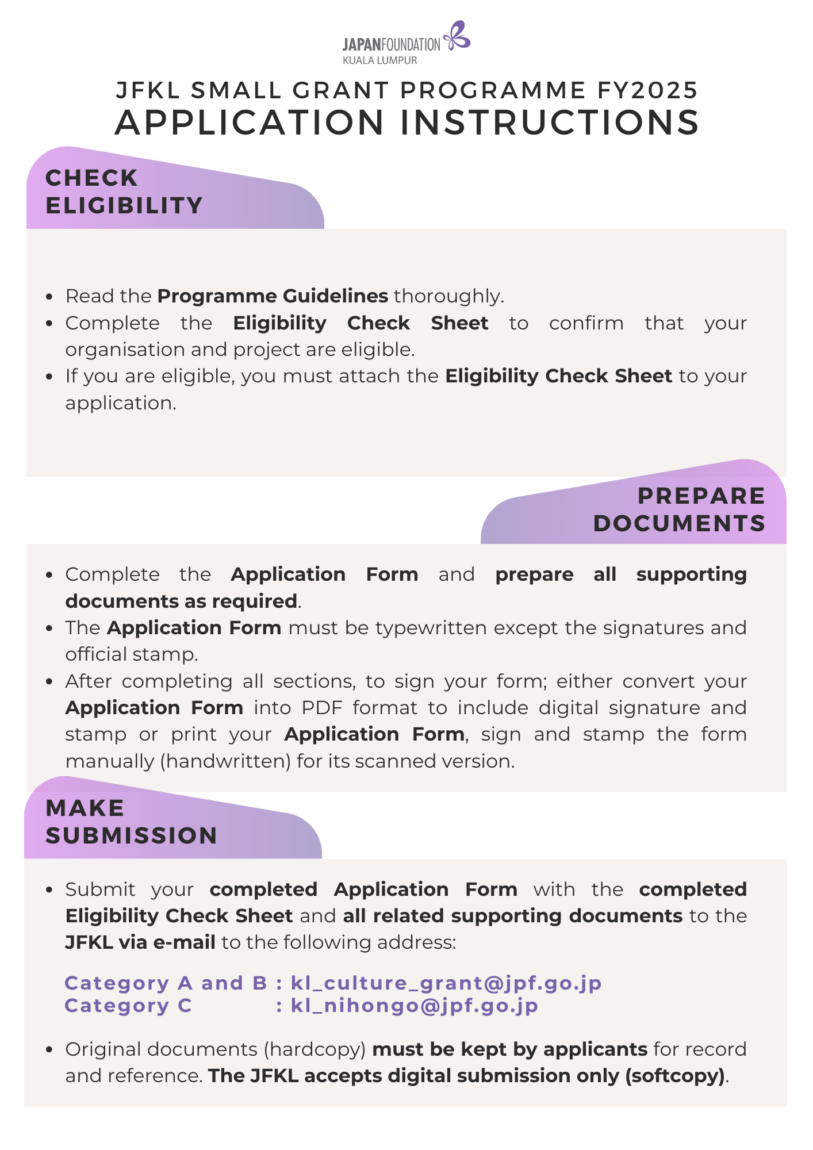



**JFKL Small Grant Programme FY2025**

**Application Form**

|  |  |  |  |  |  |  |  |  |  |  |  |  |
| --- | --- | --- | --- | --- | --- | --- | --- | --- | --- | --- | --- | --- |
|  | **Date:** | | | | | | | | Click or tap to enter date of application | | | |
| **1.** | **Title of the Project:** | | | | | | | | | | | |
|  | Enter the title/name of your project | | | | | | | | | | | |
|  |  | | | | | | | | | | | |
| **2.** | **Category of the Project:**  *Please check/choose relevant box* | | | | | | | | | | | |
|  | **Category A: Japanese Arts and Cultural Exchange** | | | | | | | | | | | |
|  | Performance | | | | Exhibition | | | | | Film Screening | | |
|  | Publication | | | | Other: Enter here | | | | |  | | |
|  | **Category B: Japanese Studies and Global Partnerships** | | | | | | | | | | | |
|  | Conference/Seminar/Workshop/Masterclass | | | | | | Publication | | | Other: Enter here | | |
|  | **Category C: Japanese Language Education** | | | | | | | | | | | |
|  | Conference | | | | Teacher Training | | | | | Publication of Teaching Resources | | |
|  | Support for Resource Centre/Library | | | | | | | | | Other: Enter here | | |
|  |  | | | | | | | | | | | |
| **3.** | **Types of the Project:** | | | | | | | | | | | |
|  | Physical | | | | Online | | | | | Hybrid (Physical & Online) | | |
|  |  | | | | | | | | | | | |
| **4.** | **Project Period:** The project must be organised/conducted between 1 April 2025 to 31 March 2026 | | | | | | | | | | | |
|  | From | Click or tap to enter your start date | | | | | | To | | Click or tap to enter your finish date | | |
|  |  | | | | | | | | | | | |
| **5.** | **Project Venue(s) / Online Platform(s):** | | | | | | | | | | | |
|  | State the venue or platform of your project | | | | | | | | | | | |
|  |  | | | | | | | | | | | |
| **6.** | **Organisation Information:** | | | | | | | | | | | |
|  | **Name of Organisation** | | **:** | Specify the name of your organisation in full | | | | | | | | |
|  | **Name of Section that conducts the Project** | | **:** | *(e.g., Division, Faculty, Department, Sector, etc.)* | | | | | | | | |
|  | Specify the section in charge of this project under your organisation | | | | | | | | |
|  | **Legal Status** | | **:** | Specify the legal status of your organisation | | | | | | | | |
|  | **Registration Number** | | **:** | Enter the registration number of your organisation | | | | | | | | |
|  | **Year of Registration** | | **:** | Enter the year of registration of your organisation | | | | | | | | |
|  | **Office Address** | | **:** | Enter the full address of your organisation | | | | | | | | |
|  | **Office Number** | | **:** | **Tel:** | | Enter the phone number | | | | | **Fax:** | Enter the fax number |

|  |  |
| --- | --- |
| **NOTE: PLEASE USE A SEPARATE SHEET WHEREVER NECESSARY** | |
| **7.** | **Organisation Background:**  *For private organisation, please attach the registration certificate and recent audited financial report.* |
|  |  |
|  | Write the background of your organisation |
|  |  |
| **8.** | **Objectives of the Project:**  *Please state how your project can contribute to the objective of the grant.* |
|  |  |
|  | Write the objectives of the project |
|  |  |
| **9.** | **Project Description:**  *Please clarify how you plan to achieve the expected outcome described below through the proposed project.* |
|  |  |
|  |  |
|  | *\*Please submit the detailed descriptions of the project (project proposal) and related supporting documents.* |
|  |  |

|  |  |  |  |  |  |  |
| --- | --- | --- | --- | --- | --- | --- |
| **10.** | **Major Collaborators / Collaborating Institutions:**  *Please attach the supporting documents (i.e., Letter of collaboration, etc.) if possible.*  *Please include the support from any Japanese governmental organisations or agencies including the Embassy of Japan, Consulate-General of Japan and Consular Office of Japan, if any.* | | | | | |
|  |  | | | | | |
|  | **Country & Name of Institutions / Collaborators** | | | | **Roles** | |
|  | Write the name of collaborators as detailed as possible | | | | State the role(s) of each collaborator | |
|  |  | | | | | |
| **11.** | **Proposed Schedule:**  *Please state the full schedule of your project including post-event (i.e., submission of final report, etc.)* | | | | | |
|  |  | | | | | |
|  | **Date/Period** | | | **Activities** | | **Project Site / Venues / Platforms** |
|  | Write the date/period as detail as possible | | | Write the activities/task/progress of your project | | Write the site/venues/platforms of the activities |
|  |  | | | | | |
| **12.** | **Expected Output:**  *Please state how the project can contribute to the larger number of audience/participants & public.* | | | | | |
|  |  | | | | | |
|  | Write the project expected outcomes | | | | | |
|  | ***Continuation of Project:***  *Do you have plans for a different project as a continuation of, or related to this proposed project?* | | | | | |
|  |  | **YES** | If yes, please state the plan(s) in general: | | | |
|  |  | **NO** | Write your future plans, if any e.g. name of project, content, date, venue, etc. | | | |
|  |  |  |

|  |  |  |  |  |  |
| --- | --- | --- | --- | --- | --- |
| **13.** | **Public Relation (PR) plan for both before and after the project implementation:** | | | | |
|  |  | | | | |
|  | Write your PR plan as detailed as possible | | | | |
|  |  | | | | |
|  | **\*Checklist for Ticketing Events:**  *Complete this section if relevant to your project.* | | | | |
|  |  | | | | |
|  | **Event** | **Ticket Price / Participation fees** | | | **Number of estimated audiences** |
|  | **1.** Event name | **Adult** | **:** | RM Amount | No. of **people** |
|  | **Concessions** | **:** | RM Amount |
|  | **2.** Event name | **Adult** | **:** | RM Amount | No. of **people** |
|  | **Concessions** | **:** | RM Amount |
|  | **3.** Event name | **Adult** | **:** | RM Amount | No. of **people** |
|  | **Concessions** | **:** | RM Amount |
|  | **Total number of estimated audiences:** | | | | **No. of people** |
|  | **Will you apply for visa for the artist & permit for performance?** | | | Yes | No, because: |
|  | If no, state the reason(s) here |
|  |  | | | | |

|  |  |  |  |  |  |  |  |  |
| --- | --- | --- | --- | --- | --- | --- | --- | --- |
| **14.** | **Budget Proposal (In Ringgit Malaysia)**  **SAMPLE**  *All budget items for the project, including those covered by the applicant and other funding sources, should be included in the Project Total Cost.*  *All cost should be stated only in Ringgit Malaysia (MYR), including for applicants from Singapore and Brunei by referring to MUFG current conversion rate.* | | | | | | | |
| **Each cost breakdown must be written clearly.**  **Specify each item as detailed as possible.**  **(A) FULL COST FOR PROJECT** | | | | |  | **(B) BREAK DOWN OF COST SHARING (MYR)**  Cost coverage and in-kind support | | |
| Minimum 20% of the full cost | | Maximum 80% of the full cost |
| **Items** | | **Specification** | **Cost Breakdown** | **Total Cost (MYR)** |  | **Applicant’s Own Expenses** | **Other Funding Sources** | **Grant from JFKL** |
| **(1)** | **Honorarium** | Speaker 1: Dr. Yoshida Masayoji  Speaker 2: Ms. Sakura Kyo | RM 1,000.00 X 1 day X 2 speakers | 2,000.00 | **→** |  | 1,000.00 | 1,000.00 |
| **(2)** | **Per diem** | Speaker’s daily meals | RM 100.00 X 1 day X 2 speakers | 200.00 | **→** |  | 200.00 |  |
| **(3)** | **Transportation** | Route, Class, etc. | Dr. Yoshida: RM 3,489.00 (Roundtrip)  Dr. Sakura: RM 3750.00 (Roundtrip) | 7,239.00 | **→** |  | **Quotation/invoice/etc for all cost to be covered under JFKL must be attached with this application form.** | 7,239.00 |
| **a. International** | Dr. Yoshida: MAS (economy) 01 May 25: NRT-KUL- MH9117 04 May 25: KUL-NRT MH70  Dr. Sakura: Air Asia (economy) 01 May 25: KIX-KUL- D7533 04 May 25: KUL-KIX -D7532 |
| **b. Domestic**  **(within Malaysia)** | Grab (roundtrip): Cititel Mid Valley - Dewan Seri Negeri for rehearsal and event day | RM 30.00 X 4 trips | 120.00 | **→** | 120.00 |  |  |
| **(4)** | **Accommodation** | Hotel Cititel Mid Valley: Deluxe Room  01 May 25- 04 May 25 | RM 250.00 X 3 nights X 2 speakers | 1,500.00 | **→** |  |  | 1,500.00 |
| **(5)** | **Publicity / PR** | Facebook paid advertisements:  01 April-15 April | RM 40.00 X 15 days | 600.00 | **→** | 600.00 |  |  |
| **(6)** | **Fee for rental of venue & equipment** | Venue: Dewan Seri Negeri  01 May 25 (max: 500 pax)  Equipment: PA system and projector | RM 4,000.00 X 1 day  RM 1,000.00 X 1 day | 5,000.00 | **→** |  | 1,000.00 | 4,000.00 |
| **(7)** | **Report / Printing** | Event flyers (A5)-full colour  Event posters (A3)- full colour | RM 1.50 X 100 pieces  RM 2.00 x 10 pieces | 170.00 | **→** | 170.00 |  |  |
| **(8)** | **Fee for visa and permit** |  |  |  | **→** |  |  |  |
| **(9)** | **Fee for translator / interpreter** | Interpreter: Ms. Aina Nabila  2 days | RM 100.00 X 5 hours X 2 days | 1,000.00 | **→** | 1,000.00 | **Total amount under JFKL grant must be lesser than 80% of overall cost.** |  |
| **(10)** | **Others** |  |  |  | **→** |  |  |  |
| **Project Total Cost:** | | | | **17,829.00** | **→** | **1,890.00** | **2,200.00** | **13,739.00** |

|  |  |  |  |  |  |  |  |  |
| --- | --- | --- | --- | --- | --- | --- | --- | --- |
| **14.** | **Budget Proposal (In Ringgit Malaysia)**  *All budget items for the project, including those covered by the applicant and other funding sources, should be included in the Project Total Cost.*  *All cost should be stated only in Ringgit Malaysia (MYR), including for applicants from Singapore and Brunei by referring to MUFG current conversion rate.* | | | | | | | |
|  |  | | | | | | | |
| **(A) FULL COST FOR PROJECT** | | | | |  | **(B) BREAK DOWN OF COST SHARING (MYR)**  Cost coverage and in-kind support | | |
| Minimum 20% of the full cost | | Maximum 80% of the full cost |
| **Items** | | **Specification** | **Cost Breakdown** | **Total Cost (MYR)** |  | **Applicant’s Own Expenses** | **Other Funding Sources** | **Grant from JFKL** |
| **(1)** | **Honorarium** | Click or tap here to enter text. | Click or tap here to enter text. | 00.00 | **→** | 00.00 | 00.00 | 00.00 |
| **(2)** | **Per diem** | Click or tap here to enter text. | Click or tap here to enter text. | 00.00 | **→** | 00.00 | 00.00 | 00.00 |
| **(3)** | **Transportation** | Route, Class, etc. | Click or tap here to enter text. | 00.00 | **→** | 00.00 | 00.00 | 00.00 |
| **a. International** | Click or tap here to enter text. |
| **b. Domestic**  **(within Malaysia)** | Click or tap here to enter text. | Click or tap here to enter text. | 00.00 | **→** | 00.00 | 00.00 | 00.00 |
| **(4)** | **Accommodation** | Click or tap here to enter text. | Click or tap here to enter text. | 00.00 | **→** | 00.00 | 00.00 | 00.00 |
| **(5)** | **Publicity / PR** | Click or tap here to enter text. | Click or tap here to enter text. | 00.00 | **→** | 00.00 | 00.00 | 00.00 |
| **(6)** | **Fee for rental of venue & equipment** | Click or tap here to enter text. | Click or tap here to enter text. | 00.00 | **→** | 00.00 | 00.00 | 00.00 |
| **(7)** | **Report / Printing** | Click or tap here to enter text. | Click or tap here to enter text. | 00.00 | **→** | 00.00 | 00.00 | 00.00 |
| **(8)** | **Fee for visa and permit** | Click or tap here to enter text. | Click or tap here to enter text. | 00.00 | **→** | 00.00 | 00.00 | 00.00 |
| **(9)** | **Fee for translator / interpreter** | Click or tap here to enter text. | Click or tap here to enter text. | 00.00 | **→** | 00.00 | 00.00 | 00.00 |
| **(10)** | **Others** | Click or tap here to enter text. | Click or tap here to enter text. | 00.00 | **→** | 00.00 | 00.00 | 00.00 |
| **Project Total Cost:** | | | | **00.00** | **→** | **00.00** | **00.00** | **00.00** |

|  |  |  |  |  |  |  |  |  |  |  |  |
| --- | --- | --- | --- | --- | --- | --- | --- | --- | --- | --- | --- |
| **15.** | **Bank Account:**  *In case the name of the account holder differs from the name of the applying organisation, a letter of attorney which describes the reason of delegation in needed if JFKL decides to award the grant.* | | | | | | | | | | |
|  |  | | | | | | | | | | |
|  | **Bank Name** | | | | | **:** | Name of bank in full | | | | |
|  | **Branch Name** | | | | | **:** | Name of branch (location) | | | | |
|  | **Address** | | | | | **:** | Address of bank | | | | |
|  | **Account Number** | | | | | **:** | Account number | | | | |
|  | **Bank Code / IBAN for 24 European Nations** | | | | | **:** | Click or tap here to enter text. | | | | |
|  | **Bank Code / BIC / Swift Code for 24 European Nations** | | | | | **:** | Click or tap here to enter text. | | | | |
|  | **Name of the Account** | | | | | **:** | Name of the account holder (organisation/institution) | | | | |
|  | **Address of the Account** | | | | | **:** | Address of the account | | | | |
|  |  | | | | | |  | | | | |
| **16.** | **Endorsement:**  *The Contact Person and the Project Director may be the same individual.*  *However, the Project Director and the Bursar must be two different individuals.* | | | | | | | | | | |
|  |  | | | | | | | | | | |
|  | **(A) Contact Person** | | | | | | | | | | |
|  | **Name** | | **:** | Full name with title | | | | | | | |
|  | **Position/Designation** | | **:** | Position/designation of the contact person in the organisation | | | | | | | |
|  | **Contact Number** | | **:** | **Tel:** | | | Enter the phone number | **Fax:** | Enter the fax number | | |
|  | **E-mail Address** | | **:** | E-mail address of the contact person for correspondence | | | | | | | |
|  | **Signature** | | **:** |  | | | | | | | |
|  |  | **This Contact Person is also the Project Director** *\*If checked, not required to fill in (B) Project Director below* | | | | | | | | | |
|  |  | |  |  | | | | | | | |
|  | **(B) Project Director** | | | | | | | | |  | **OFFICIAL STAMP** |
|  | **Name** | | **:** | | Full name with title | | | | |  |
|  | **Position/Designation** | | **:** | | Position/designation of the project director in the organisation | | | | |  |  |
|  | **E-mail Address** | | **:** | | E-mail address of the project director | | | | |  |
|  | **Signature** | | **:** | |  | | | | |  |
|  |  | | | |  | | | | |  |
|  | **(C) Bursar** | | | | | | | | |  |
|  | **Name** | | **:** | | Full name with title | | | | |  |
|  | **Position/Designation** | | **:** | | Position/designation of the bursar in the organisation | | | | |  |
|  | **E-mail Address** | | **:** | | E-mail address of the bursar | | | | |  |
|  | **Signature** | | **:** | |  | | | | |  |

**Application Documents:**

*Please ensure to complete all sections of this application form and attach all related supporting documents.*

*Confirm the checklist below before submitting your application to JFKL:*

|  |  |  |  |
| --- | --- | --- | --- |
| **JFKL SMALL GRANT PROGRAMME FY2025**  **APPLICATION CHECKLIST** | | | |
| **No.** | **Document** | **\*Related section in Application Form** | **☒** |
| 1. | Application form (this document) |  |  |
| 2. | Eligibility check sheet |  |  |
| 3. | **< Supporting Documents >** |  |  |
| (i) | Organisation’s registration certificate, recent audited financial report | No. 7 |  |
| (ii) | Information on the applicant’s organisation | No. 7 |  |
| (iii) | Detailed project proposal (including a report of past similar project, if any) | No. 8, No. 9, No. 11, No. 12, No. 13, No. 15 |  |
| (iv) | Profile, biography or CV of guest/collaborator (artist, researcher, collaborating institutions, etc.) | No. 10 |  |
| (v) | Agreement with the guest/collaborator (in a form of a letter, e-mail or contract) | No. 10 |  |
| (vi) | Quotations, proforma invoice or any written forms to prove the cost as per request in the budget proposal | No. 15 |  |
| (vii) | Other:  State the document here |  |  |
| Other:  State the document here |  |  |
| Other:  State the document here |  |  |
| Other:  State the document here |  |  |
| Other:  State the document here |  |  |
| Other:  State the document here |  |  |

*Applicant must complete all related section in the application form **AND** attach the supporting documents.

|  |  |  |  |
| --- | --- | --- | --- |
| Kindly mark related box(es): | | | |
| **How or where did you discover this grant opportunity?** | | | |
|  | JFKL website |  | Friend |
|  | JFKL Facebook |  | Colleague or own organisation/institution |
|  | JFKL Instagram |  | Japanese organisations/agencies |
|  | JFKL newsletter |  | Social media (other than JFKL) |
|  | JFKL staff |  | Other: State the platform etc. |